VIETNAM INTERNATIONAL UNIVERSITY – HO CHI MINH CITY INTERNATIONAL

UNIVERSITY WEB APPLICATION DEVELOPMENT PROJECT

**COOKCOOK – THE COOKING RECIPE WEBSITE**

By

|  |  |  |  |
| --- | --- | --- | --- |
| Name | ID | Contribution | Percentage |
| Trần Hoàng Thế Bảo | ITITIU21123 | Front-end + Leader | 25% |
| Hoa Hoàng Trí Phúc | ITITIU21283 | Back-end | 25% |
| Đinh Hoàng Thảo Nguyên | ITITWE20008 | UI/UX + Front-end | 25% |
| Trần Đặng Phương Nam | ITITIU21083 | Front-end | 25% |

Advisor: Dr. Nguyen Van Sinh

A report submitted to the School of Computer Science and Engineering in partial fulfillment of the requirements for the Final Project in Web Application Development course - Fall 2024

Ho Chi Minh city, Vietnam, 2024

Table of Contents

I. INTRODUCTION 3

II.  REQUIREMENT ANALYSIS AND DESIGN 9

REQUIREMENT ANALYSIS 9

A. FUNCTIONAL REQUIREMENTS FOR COOKCOOK WEBSITE 9

B. NON-FUNCTIONAL REQUIREMENTS FOR COOKCOOK WEBSITE 17

III. IMPLEMENTATION 20

Homepage 20

Login Page 21

Sign-Up Page 22

About Us Page 23

Category Page 23

Recipe Page 26

CookCook News Page 29

Add to Wishlist Page 29

Summary 30

IV. DISCUSSION AND CONCLUSION 31

V. REFERENCES 32

# **INTRODUCTION**

This section briefly introduces the background information of our web development team - Masterchef. More importantly, the basic information about our project is also mentioned in this part. Furthermore, the constraints during our project are included at the end of this section.

1. **ABOUT US**

   We are pleased to introduce CookCook, an online platform for cooking enthusiasts. CookCook not only shares thousands of diverse recipes from around the world but also provides detailed instructions with appealing images and videos.

   In addition to exploring dishes, users can share their own recipes, rate, and comment. With CookCook, cooking becomes more enjoyable and easier than ever. Join us to explore a world of culinary creativity!



**Figure 1.1**

1. **VISION**

   Our vision is to become a global leader in the online culinary space, fostering a vibrant community of food enthusiasts who are empowered to explore, create, and share their culinary journeys. We aspire to be a trusted source of inspiration and knowledge for anyone passionate about cooking, from amateur cooks to seasoned professionals.

   We also envision a platform that transcends cultural boundaries, bringing together diverse culinary traditions from around the world. By doing so, we hope to promote cultural exchange and understanding through the universal language of food.

1. **MISSION**

Our mission is to create a user-friendly, interactive, and comprehensive platform that supports and inspires individuals in their culinary endeavors. We aim to provide:

* **A diverse collection of recipes:** From simple, everyday meals to complex gourmet dishes, catering to all skill levels and dietary needs.
* **Educational resources:** Offering users valuable cooking tips, techniques, and nutritional information to help them make informed choices.
* **A supportive community:** Encouraging users to share their recipes, cooking experiences, and feedback, fostering a sense of belonging and collaboration.
* **Convenient access:** Ensuring that our platform is accessible on various devices, allowing users to find inspiration and guidance anytime, anywhere.

1. **DEVELOPMENT PROCESS**

  The development of our recipe website followed an **Agile methodology** to ensure flexibility and continuous improvement. The key stages of the process are as follows:

* **Planning and Requirement Gathering:**  
  Our development team conducted thorough market research and user surveys to identify the essential features for the website. The primary objective was to build a platform that not only provides a vast collection of recipes but also fosters a community where users can share experiences and learn from one another. The main requirements included:
  + Supporting recipe search by category, ingredients, and dietary preferences.
  + Allowing users to register accounts, save favorite recipes, and contribute their own.
  + Offering detailed cooking instructions and nutritional tips.
* **Design:**  
  The design team focused on creating an intuitive and user-friendly interface. Wireframes and mockups were developed with a clean and clear layout, emphasizing easy navigation. The design highlights include:
  + A homepage featuring sections like **Recipes By Country**, **Dietary Recipes**, and **Recipes by Cooking Method**.
  + A search bar enabling users to quickly find desired recipes.
  + Simple, visually appealing aesthetics to enhance user experience.
* **Development:**  
  In the development phase, the team translated the designs into a functional website using cutting-edge technologies:
  + **Front-end:**
    - **ReactJS** was utilized to build an interactive and responsive user interface, allowing users to navigate the site smoothly.
    - **Tailwind CSS** was used for styling, providing a modern and minimalistic design with consistent aesthetics.
  + **Back-end:**
    - **NodeJS** was chosen for handling server-side logic, managing data, and creating RESTful APIs to facilitate seamless communication between the front-end and back-end.
  + **Database:**
    - **MySQL** was employed to store user information, recipes, and related data.
* **Testing:**  
  After development, extensive testing was conducted to ensure the website’s functionality and performance across various devices and browsers. The testing process included:
  + **Functional Testing:** Ensuring features like recipe search, saving favorites, and posting new recipes worked as expected.
  + **User Interface (UI) Testing:** Verifying the website’s design and layout displayed correctly on both desktop and mobile devices.
  + **Performance Testing:** Ensuring fast page load times and the ability to handle high user traffic.
* **Deployment:**  
  The recipe website was deployed on a cloud server to guarantee high availability and scalability. A CI/CD (Continuous Integration/Continuous Deployment) pipeline was implemented to allow for frequent updates without disrupting the user experience.
* **User Feedback and Iteration:**  
  After the official launch, user feedback was collected to identify areas for improvement and to develop new features. Based on this feedback, features such as personalized recipe suggestions and meal planning tools are currently being developed.

1. **DEVELOPMENT ENVIRONMENT**

   The development of the recipe website was guided by the **Model-View-Controller (MVC)** architecture to ensure a clear separation of concerns and maintainability. The environment consisted of the following key components:

* **Front-end:**
  + **ReactJS:** Used to build the user interface, offering a dynamic and responsive experience. React's component-based structure allowed for reusable UI elements and efficient state management.
  + **Tailwind CSS:** Implemented for styling, providing a modern, consistent design with minimal custom CSS, ensuring a clean and user-friendly interface.
* **Back-end:**
  + **Node.js:** Used for handling server-side logic and processing user requests. Node.js was chosen for its asynchronous nature, ensuring scalability and efficient handling of concurrent requests.
  + **Express.js:** A lightweight framework used with Node.js to simplify the creation of RESTful APIs and route management.
  + **Database:**
    - **MySQL:** Utilized to store user data, recipes, and related information, ensuring efficient data retrieval and management.
* **Development Tools:**
  + **NetBeans:** The primary integrated development environment (IDE) for code writing and project management.
  + **Git & GitHub:** Used for version control, enabling collaborative development and continuous integration.
  + **Postman:** Employed for testing and debugging APIs to ensure correct data flow between the front-end and back-end.
* **Testing Frameworks:**
  + **Jest:** Used for unit and integration testing on the front-end, ensuring components and functionalities work as intended.
  + **Mocha & Chai:** Utilized for back-end testing, verifying API endpoints and server logic.
* **Deployment:**
  + The website is hosted on a cloud platform, ensuring high availability and scalability. A CI/CD pipeline is in place to automate deployments and updates, reducing downtime and improving efficiency.
  + **NGINX** is used as a reverse proxy to manage server traffic and enhance security.

This setup allowed for seamless collaboration, efficient development, and robust performance, ensuring the website delivers an exceptional user experience.

The code are implemented according to the MVC model in the **Figure 5.1**:

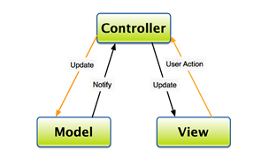

**Figure 5.1**

**1. Model:** the data of the system stored in the database and external system

**2. View:** the user interface

**3. Control:** the logics and algorithms used to develop a dynamic website with required functionalities

1. **WORK BREAKDOWN STRUCTURE**

The structure of our project can be expressed in the Figure

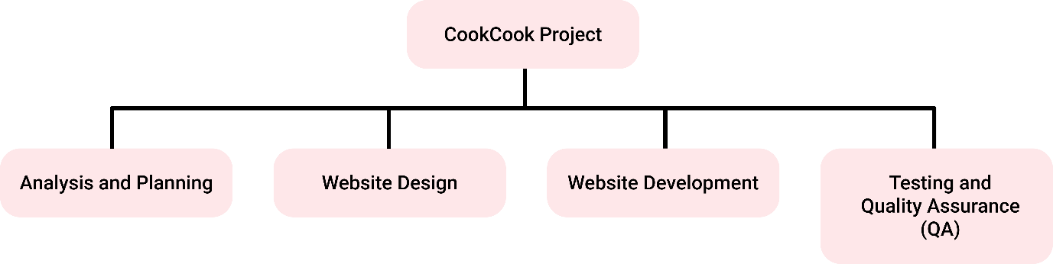**Figure 6.1**

In each branch of this tree, we also have subtrees which describes the tasks needed to be

accomplished of each team member.

The tasks for the Analysis and Planning is described in the **Figure 6.2:**

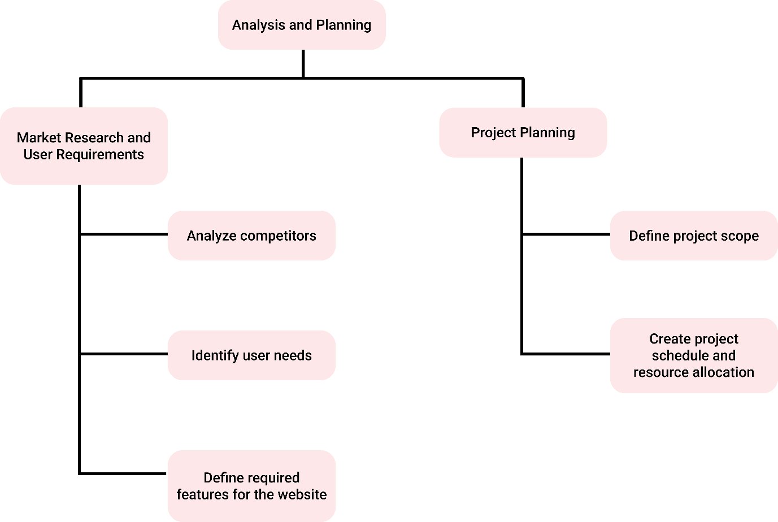The tasks for the Website Design is described in the **Figure 6.3:**

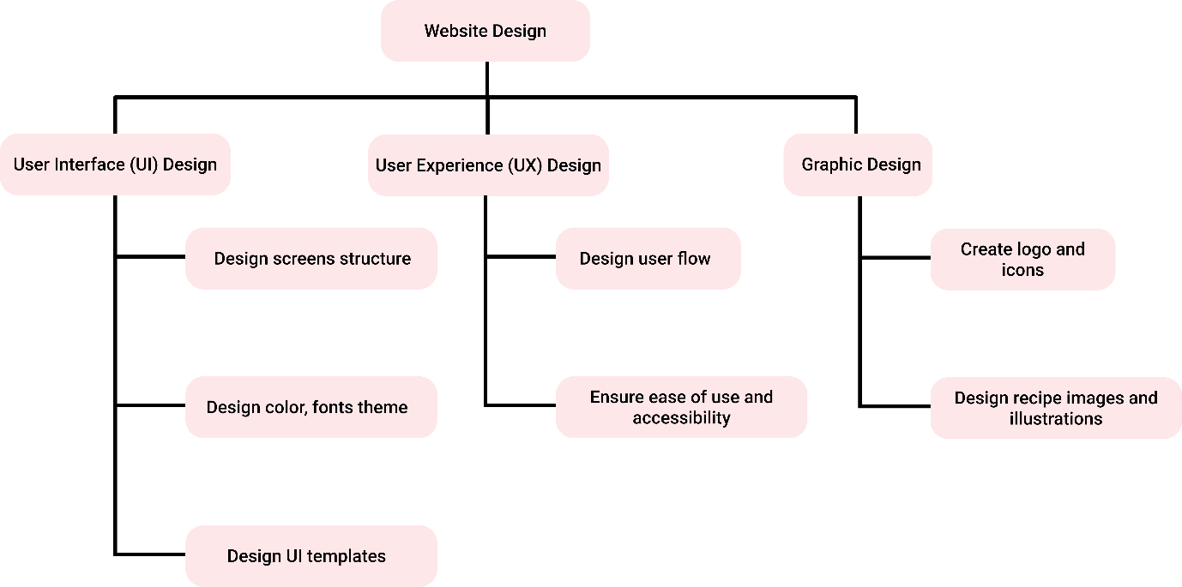The tasks for the Website Development is described in the **Figure 6.4:**

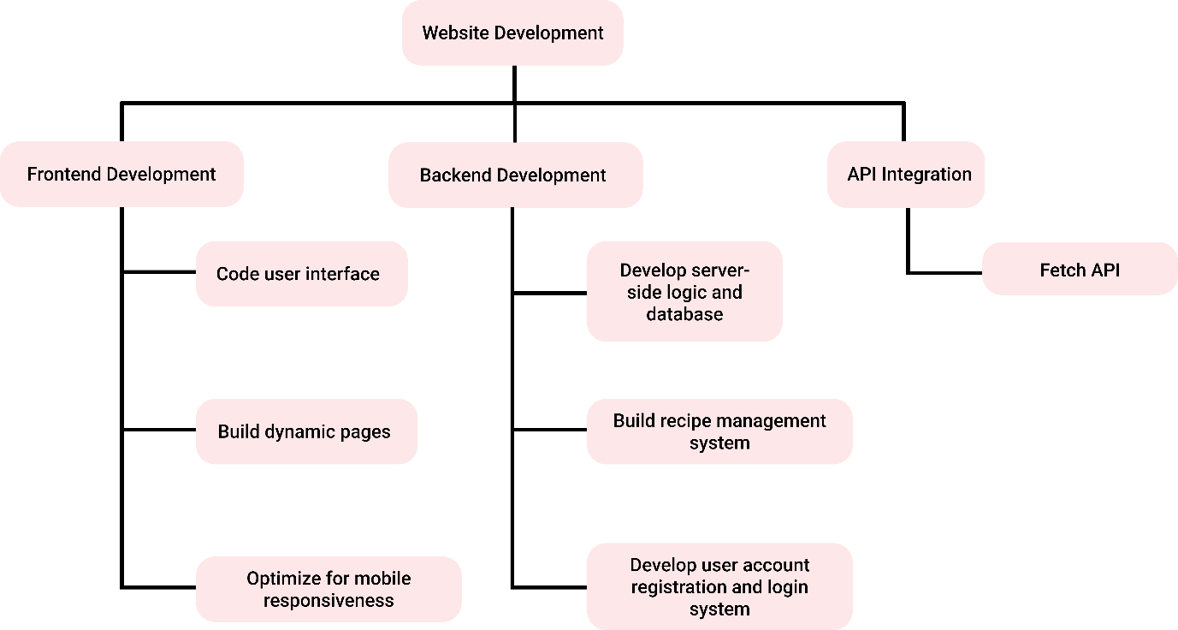

The tasks for the Testing and Quality Assurance (QA) is described in the **Figure 6.5:**

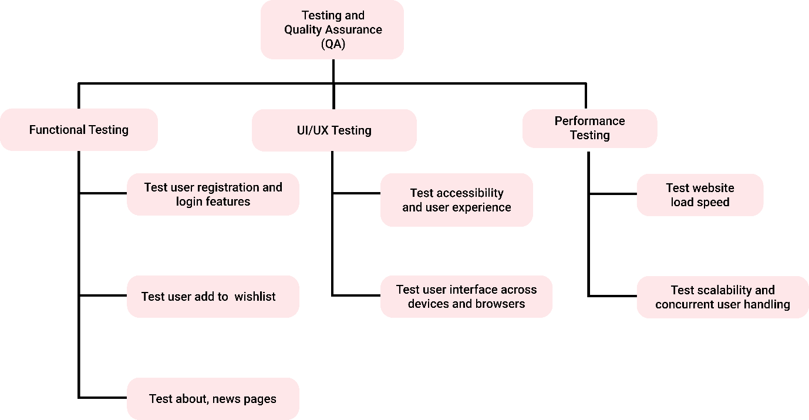

These tasks are expected to be completed and thoroughly tested after each iteration of the

development process since we aim at applying the agile method rather than the traditional one

which separates the steps.

# II.  **REQUIREMENT ANALYSIS AND DESIGN**

This section briefly introduces the requirement analysis and design process. This version is created to provide the path for future implementation of the project. Based on this requirements specification, we will implement each function including all of the conditions as well as functional and non-functional requirements supplied by the customers. During our implementation, we will constantly revise and update the newer version so that we can always keep track of the progress of the project.

## **REQUIREMENT ANALYSIS**

## **A. FUNCTIONAL REQUIREMENTS FOR COOKCOOK WEBSITE**

**USE CASE DIAGRAM**



**SYSTEM ARCHITECTURE MODEL**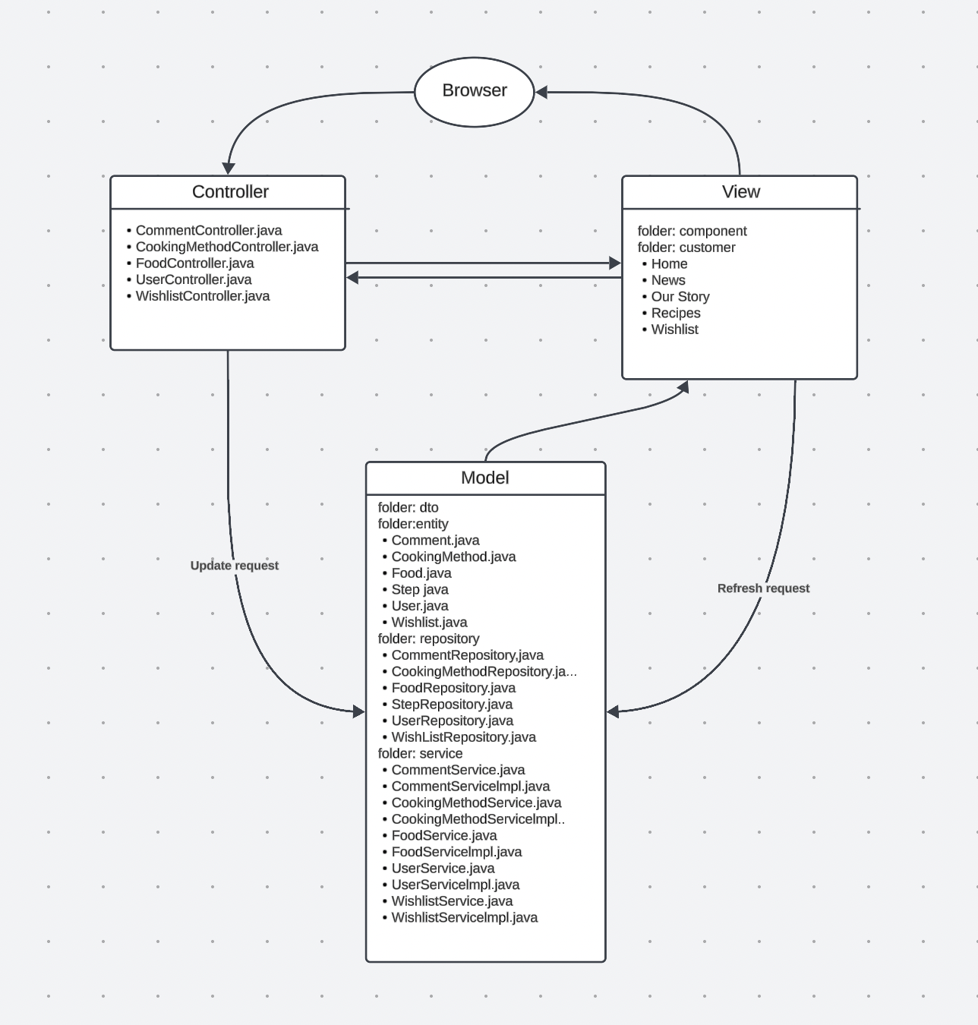

**ERD**

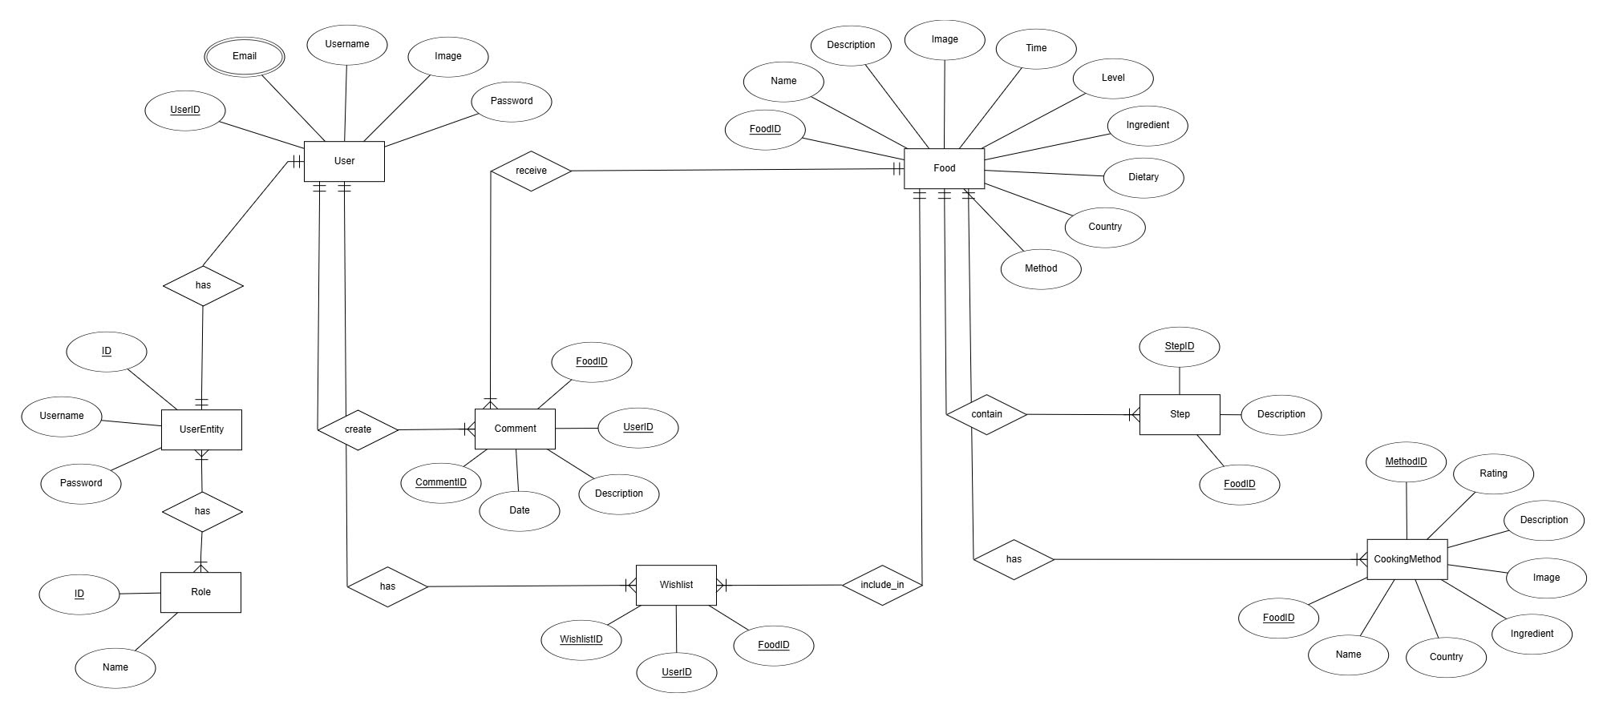

**Schema**

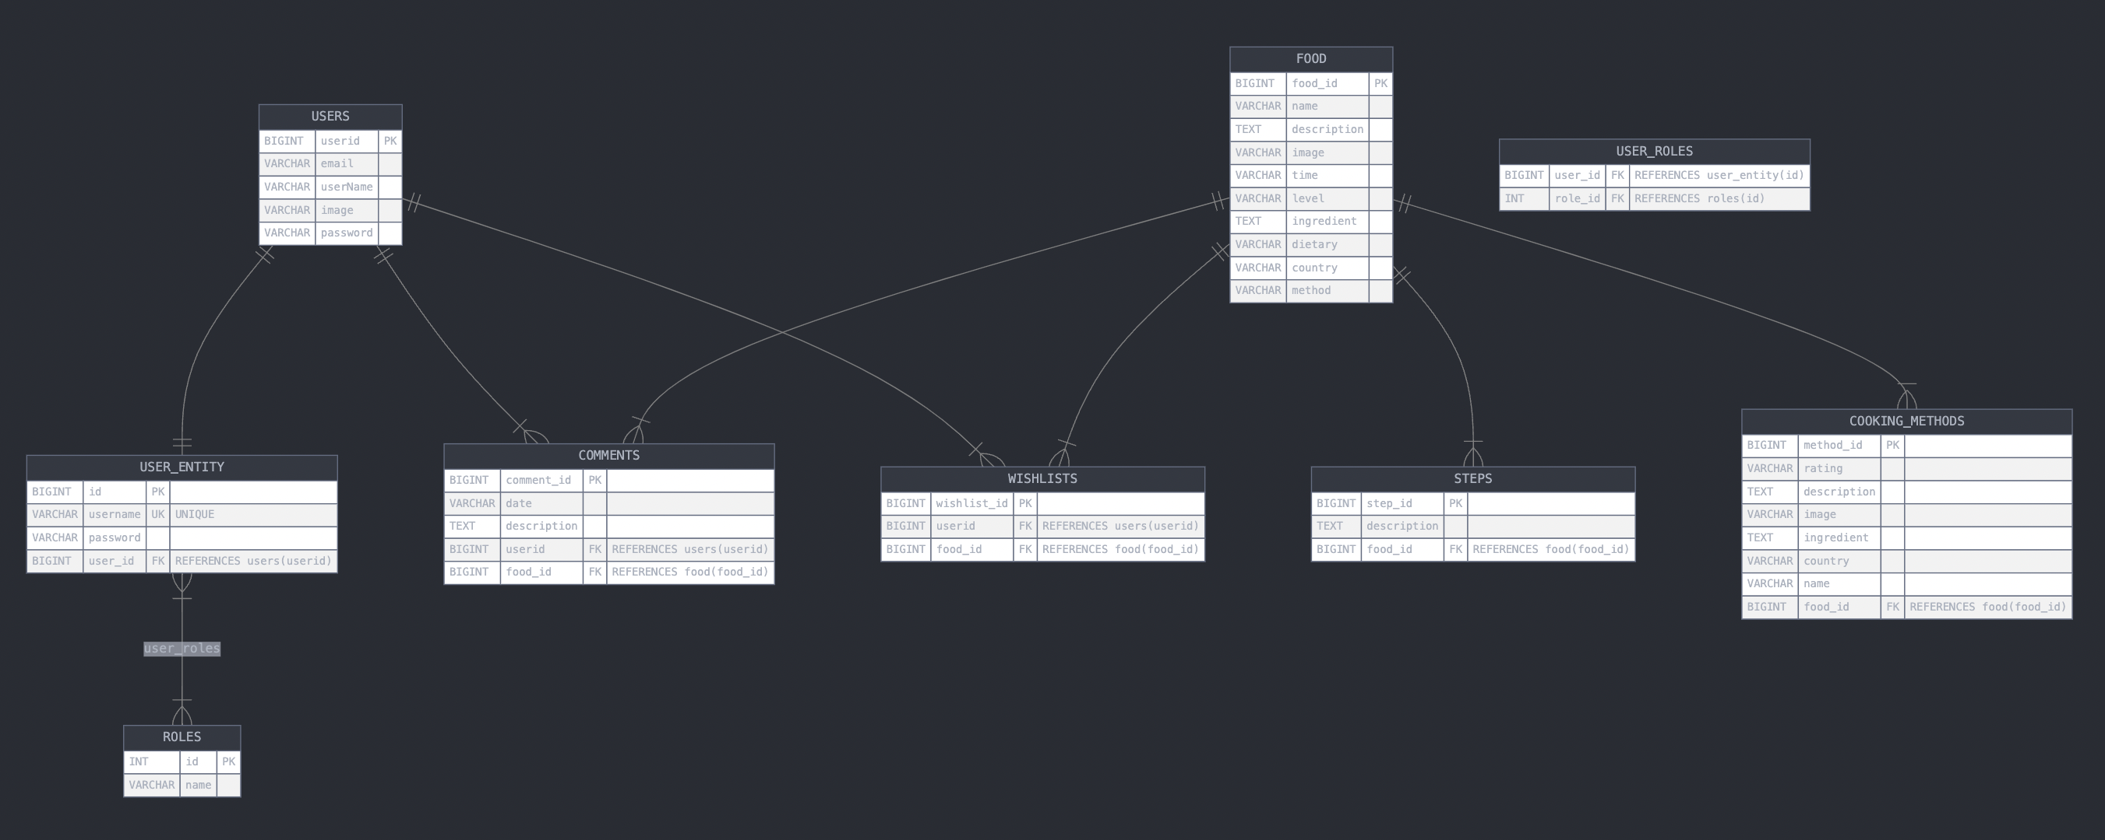

**Sequence 1:** Sign Up for an account

**Identifier:** SQ1  
**Inputs:**

* Email Address
* Password
* Confirm Password

**Outputs:**

* Confirmation of successful account creation
* An error message if any field is invalid or already registered

**Basic Course:**

|  |  |
| --- | --- |
| **Actor** | **System** |
| 1. Open the Sign-Up page | Display the Sign-Up form with input fields for Full Name, Email, Password, and Confirm Password. |
| 2. Fill in the required information | The system waits for the input. |
| 3. Submit the form | Validate the inputs (e.g., check if the email is valid and not already registered, ensure password and confirm password match). |
|  | If inputs are valid, save the account to the database and send a confirmation email. |
|  | Display a success message. |
|  | If validation fails, display appropriate error messages and remain on the Sign-Up page. |

**Preconditions:**

* The user is not currently registered on the website.
* The website is functional and accessible.

**Postconditions:**

* The user’s account is successfully saved in the system (if all inputs are valid).

**User Story:**

As a visitor to the CookCook website, I want to create an account so that I can access personalized features like saving favorite recipes and creating a wishlist.

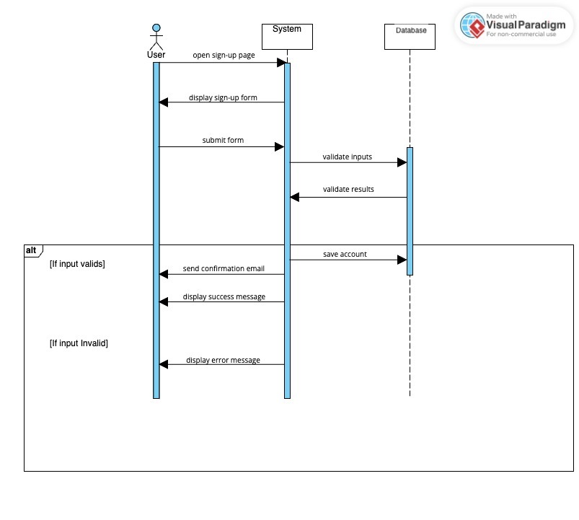

**Sequences 2: Log in to the Cooking Recipe System**  
**Identifier:** SQ2  
**Inputs:**

* Email (Username)
* Password

**Outputs:**

* The home page with the user’s personalized information (if login is successful).
* An error message (e.g., "Invalid email or password.") and the login page (if login fails).

**Basic Course:**

|  |  |
| --- | --- |
| **Actor** | **System** |
| 1. Open the login page | 1.1 The system displays the login page. |
| 2. Enter username and password | 2.1 The system waits for the username and password input. |
| 3. Submit the login form | 3.1 The system checks the user's credentials against the database. |
| 4. If credentials are correct | 4.1 The system redirects the user to the home page with authorized access. |
| 5. If credentials are incorrect | 5.1 The system returns the user to the login page with an error message. |

**Preconditions:**

* The user has an existing registered account in the Cooking Recipe System (with a valid username and password).

**Postconditions:**

* The user is either logged in and redirected to the home page or remains on the login page with an error message if the login fails.

**User Story:**

As a visitor of the cooking recipe website, I want to log in to the system so that I can access personalized features like commenting on recipes, adding recipes to my wishlist, and viewing exclusive content.

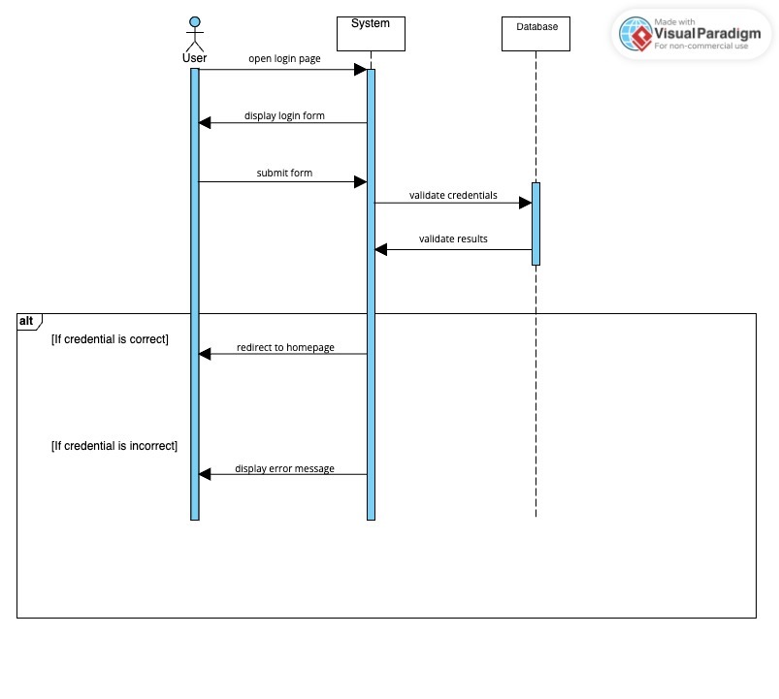

**Sequences 3: Log out of the Cooking Recipe System**  
**Identifier:** SQ3  
**Inputs:**

* None (triggered by clicking the "Log Out" button).

**Outputs:**

* Redirect to the homepage or login page with a success message (e.g., "You have been logged out.").
* Canceling log out returns the user to the previous page.

**Basic Course:**

|  |  |
| --- | --- |
| **Actor** | **System** |
| Click the "Log Out" button | Display a confirmation message: "Are you sure you want to log out?" with options "Cancel" and "OK". |
| Click "Cancel" | Close the confirmation message and return to the previous page. |
| Click "OK" | End the user session and clear any session data. |
|  | Redirect to the homepage or login page. |
|  | Display a logout confirmation message. |

**Preconditions:**

* The user is currently logged into the system.

**Postconditions:**

* The user session is terminated, and the user is redirected to a public page.

**User Story:**

As a logged-in user, I want to log out of the CookCook website so that I can securely end my session.

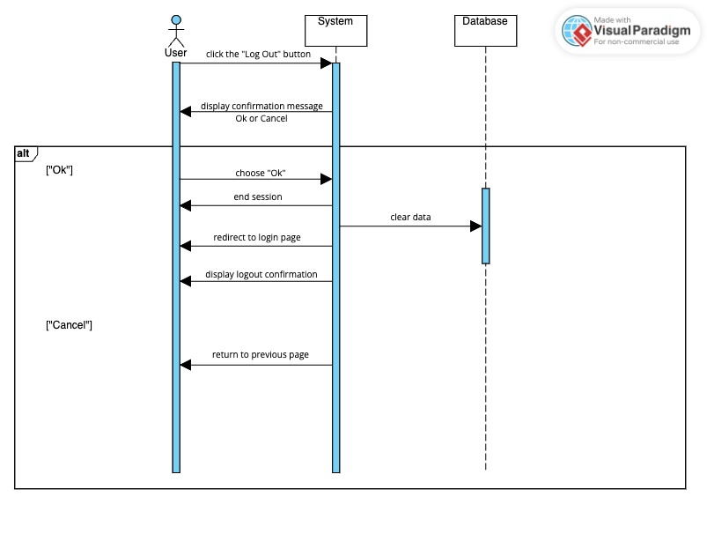

**Sequences 4: View Recipes and Add Food Recipe to Wishlist**

**Identifier:** SQ4  
**Inputs:**

* Selected food recipe (triggered by clicking the "Add to Wishlist" button).

**Outputs:**

* The selected recipe is successfully added to the wishlist.
* If already in the wishlist, display an error message (e.g., "This recipe is already in your wishlist.").

**Basic Course:**

|  |  |
| --- | --- |
| **Actor** | **System** |
| View the homepage | Display recipes with reviews as clickable images. |
| Click on a recipe image | Display the recipe details. |
| Alternatively, click the "Menu" button | Display a list of recipe categories. |
| Select a category | Display a list of recipes under the selected category. |
| Select a specific recipe | Display the recipe details. |
| Click "Add to Wishlist" | Validate if the recipe is already in the wishlist. |
|  | If not, add the recipe to the user’s wishlist and display a success message. |
|  | If the recipe is already in the wishlist, display an error message. |

**Preconditions:**

* The user is logged into the system.
* The selected recipe exists in the system.

**Postconditions:**

* The recipe is added to the user’s wishlist.

**User Story:**

As a logged-in user, I want to save food recipes to my wishlist so that I can easily access them later.

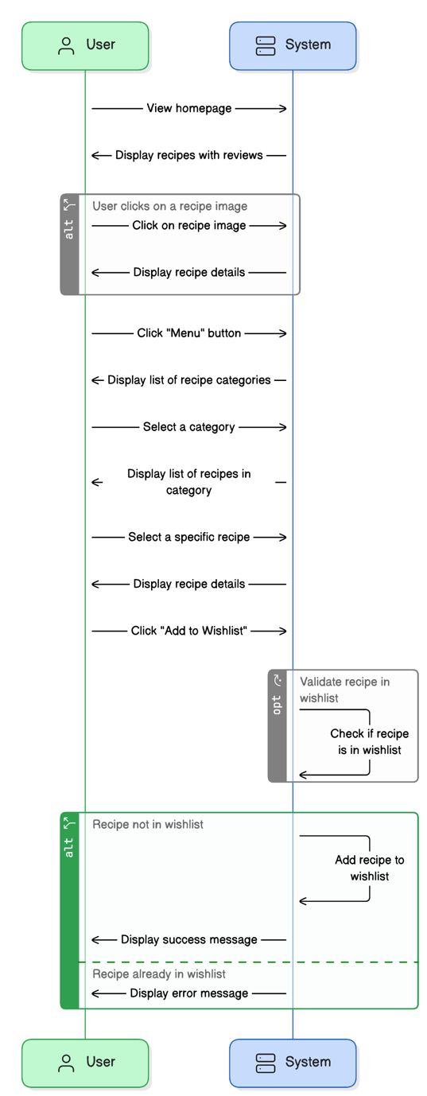

## **B. NON-FUNCTIONAL REQUIREMENTS FOR COOKCOOK WEBSITE**

#### **1. Operational Requirements:**

Ensure all components of the CookCook website operate seamlessly under various conditions.

Maintain an active, licensed hosting service capable of handling all user requests efficiently.

Assign an administrator responsible for regular updates, performance monitoring, and error management to keep the system functional and up-to-date.

#### **2. Legal Requirements:**

Credit all third-party components and libraries integrated into the website to avoid copyright infringement.

Keep proprietary source code confidential to prevent unauthorized use or distribution.

Adhere to applicable data privacy and protection laws, such as GDPR or equivalent regional regulations.

#### **3. Usability Requirements:**

Provide an intuitive interface that allows users to navigate, input data, and retrieve outputs effortlessly.

Develop well-structured user manuals and in-app guides to assist users with minimal technical expertise.

Ensure error messages are clear and offer actionable suggestions for resolution.

Design visually appealing, responsive, and user-friendly interfaces with easy navigation for all devices and platforms.

Guarantee efficiency of use, enabling users to achieve their goals with minimal errors or friction.

#### **4. Humanity Requirements:**

Design the system with a focus on accessibility for users with limited technical skills.

Provide comprehensive documentation detailing the website’s functionalities and how to use them effectively.

Develop user interfaces that are easy to learn, visually attractive, and responsive, requiring minimal effort for users to adapt.

Enhance the user experience with an aesthetic and engaging design that encourages return visits.

#### **5. Performance Requirements:**

**a. Response Requirements:**

The login response time for users must not exceed 2 seconds under normal conditions.

Changes made to the database, such as adding recipes or updating user data, must process within 1 second.

Recipe searches, category navigation, and wishlist additions should execute without noticeable delays, even during peak usage.

Website loading time must not exceed 3 seconds for users with a 5 Mbps internet connection.

**b. Throughput Requirements:**

The system must handle at least 1,000 simultaneous user sessions efficiently.

Allow seamless handling of multiple database modifications, such as updates to recipes or user accounts.

**c. Availability Requirements:**

Maintain a 99.9% uptime annually, ensuring the website is accessible at all times.

Implement efficient memory management to prevent crashes or slowdowns during high usage.

#### **6. Maintainability Requirements:**

Develop the system with clean, well-commented source code to facilitate maintenance and updates by future developers.

Design a stable and scalable database to accommodate changes without impacting existing functionalities.

Provide administrators with tools to manage content, update recipes, and address user feedback effectively.

#### **7. Support Requirements:**

Offer a dedicated support channel, such as a hotline or email, to address user issues promptly.

Provide remote maintenance tools (e.g., TeamViewer) to assist in troubleshooting technical problems.

Conduct regular system health checks and updates every two to three months to ensure stability and performance.

#### **8. Security Requirements:**

Encrypt all user data during transmission and storage using SSL and secure encryption protocols.

Implement robust login security, including restrictions after five failed attempts, locking accounts for 24 hours.

Log all administrative actions with details such as date, time, user, and changes made for accountability.

Back up all critical system data daily, with copies stored securely offsite.

Display a clear privacy policy to inform users about data handling and restrict third-party access to personal information.

#### **9. Interface Requirements:**

Ensure interface components like buttons and forms are intuitive and visually aligned with their functions.

Offer multilingual support to cater to both local and international users.

Provide clear and detailed reports for administrative and analytical purposes.

Design the interface to comply with accessibility standards, supporting users with disabilities.

By addressing these non-functional requirements, the CookCook website aims to provide a seamless, reliable, and secure experience for all users while ensuring maintainability and compliance with industry standards.

# **III. IMPLEMENTATION**

## **Homepage**

The **Homepage** of the CookCook website consists of three main sections:

1. **Task Bar**:
   1. Positioned at the top of the page, the task bar is divided into three parts:
      1. **Left Section**: Displays the name of the website, *CookCook*, along with the website’s logo.
      2. **Middle Section**: Contains navigational buttons allowing users to move to different pages of the website.
      3. **Right Section**: Shows a button labeled either "Log In" or "Log Out," depending on the user's session status.

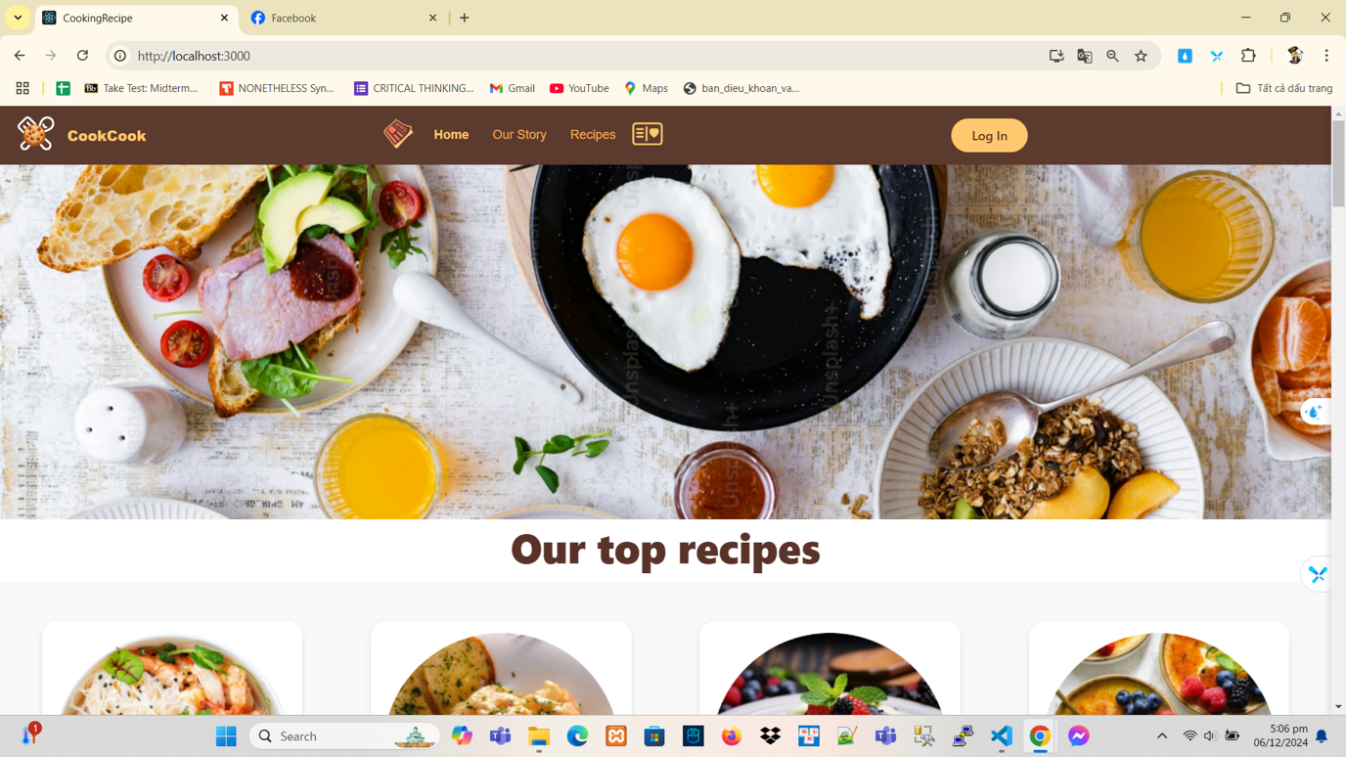

*Figure: Homepage*

1. **Featured Recipes**:
   1. This section highlights prominent recipes suggested by the website. Users can click on an image of a recipe to navigate directly to its detailed recipe page.

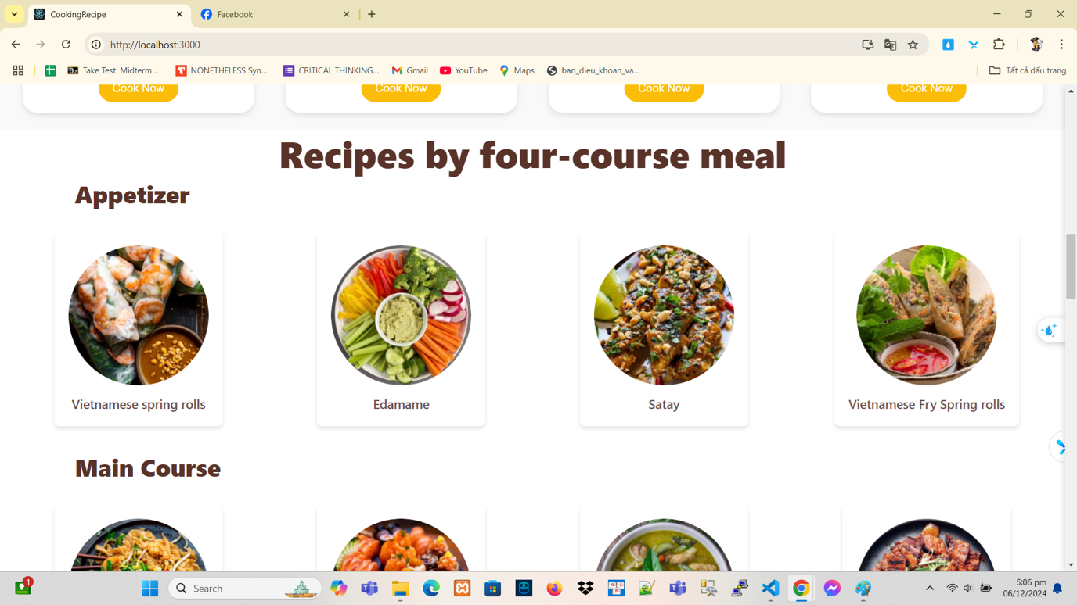

1. **Introduction**:
   1. A brief introductory paragraph or welcoming message is displayed below the featured recipes, serving as a friendly invitation to the users.

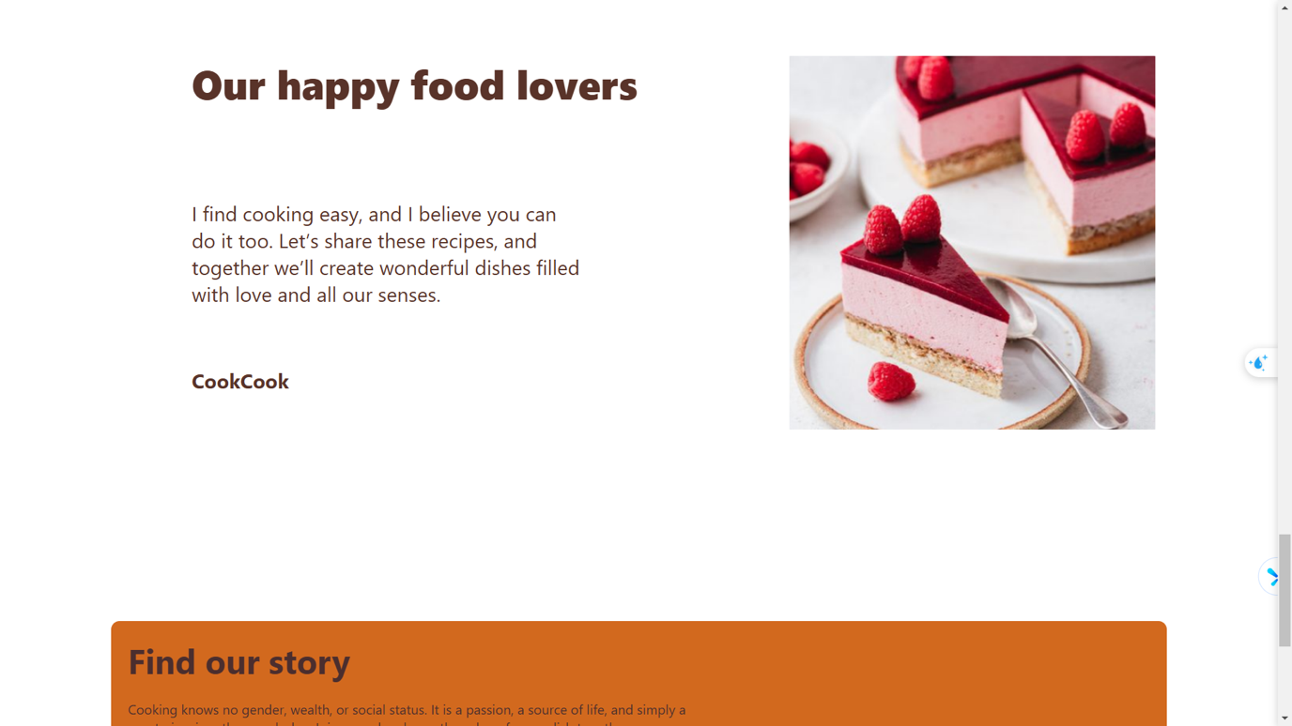

## **Login Page**

The **Login Page** allows users to access their accounts by entering their **email address** and **password**. Successful login redirects the user to the Homepage with personalized features, while invalid credentials prompt an error message to reattempt login.

*(See Figure: Login Page)*

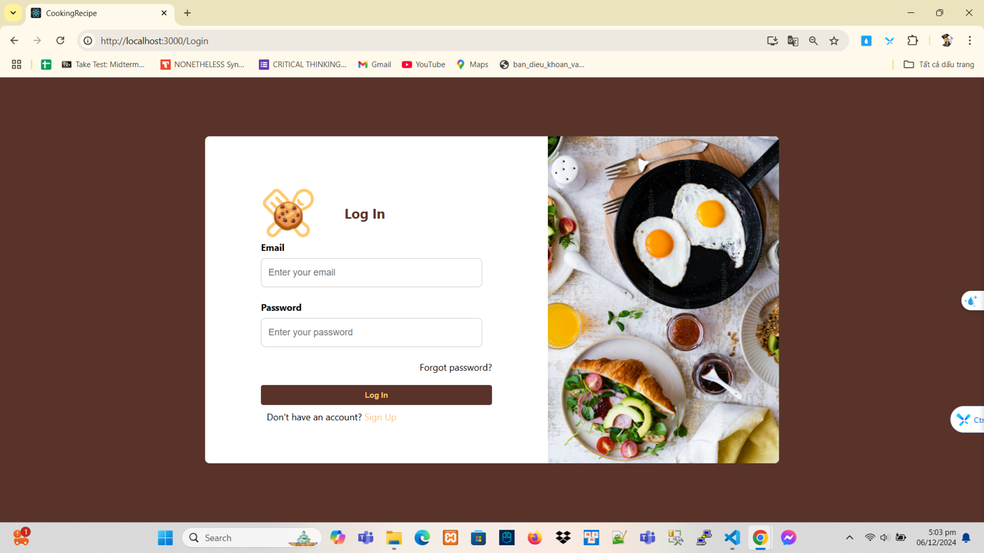

## **Sign-Up Page**

The **Sign-Up Page** is designed for users to create accounts. It includes input fields for **email address**, **password**, and **confirm password**. After submitting the form, the system validates the information, ensuring the email is unique and the passwords match. Upon successful registration, the system confirms the account creation.

*(See Figure: Sign-Up Page)*

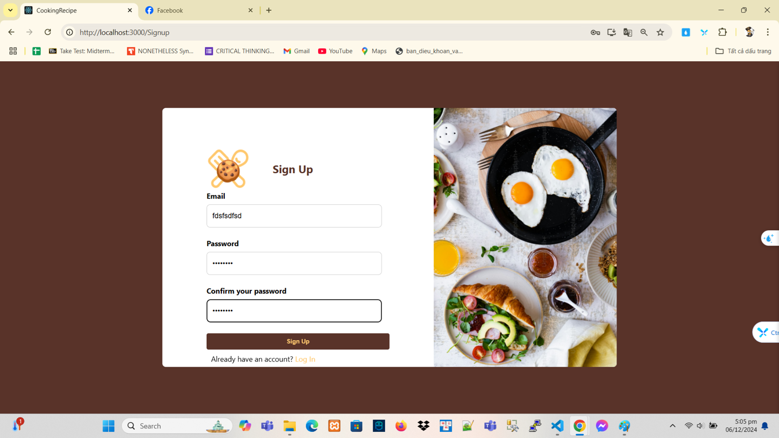

## **About Us Page**

The **About Us Page** serves as an introduction to the CookCook project, sharing its mission and vision. It includes a section called *Our Story*, providing insights into the inspiration behind the website’s creation and its purpose in helping users discover and organize recipes efficiently.

*(See Figure: About Us Page)*

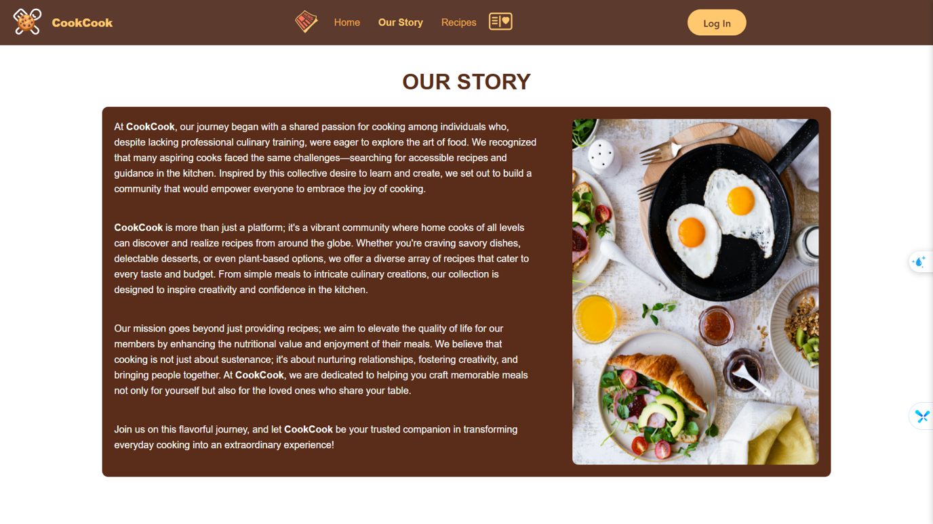

## **Category Page**

The **Category Page** is accessed by clicking the "Menu" button on the Homepage's task bar. This page lists various recipe categories.

* When a user selects a category, the page dynamically displays recipes sorted into the chosen category.
* Each recipe is clickable, allowing the user to navigate to its detailed recipe page.

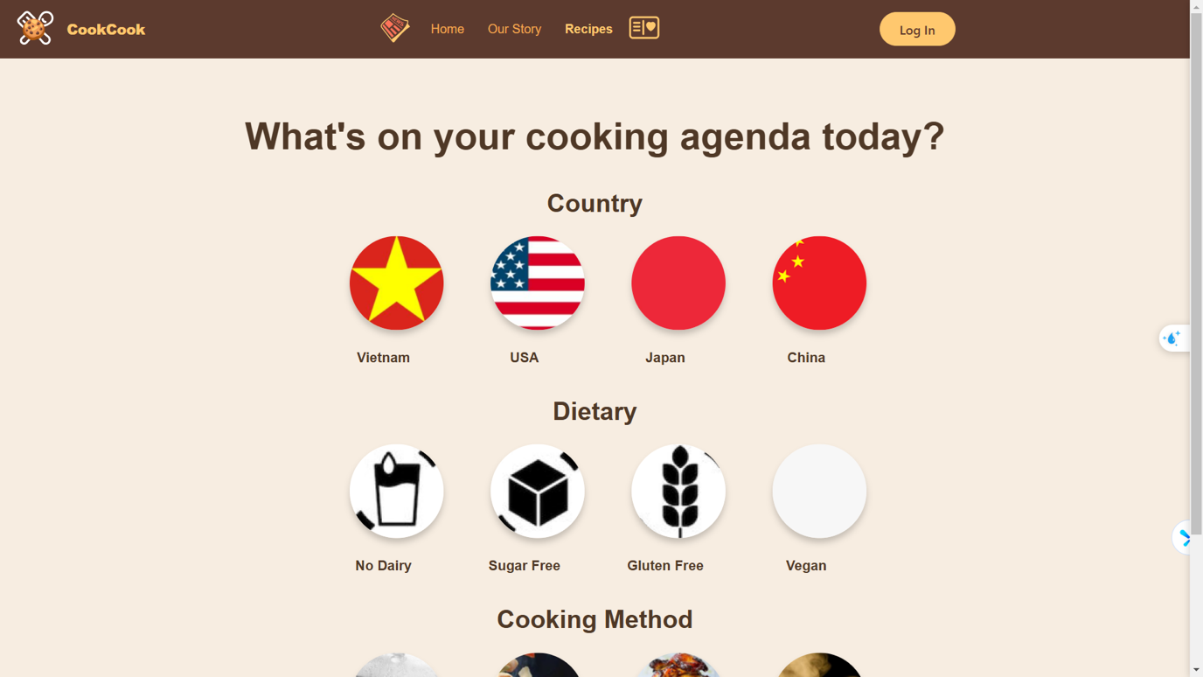

*(See Figure: Category Page)*

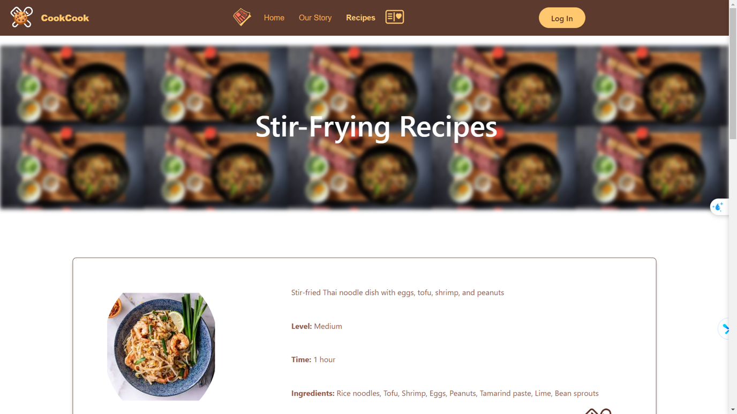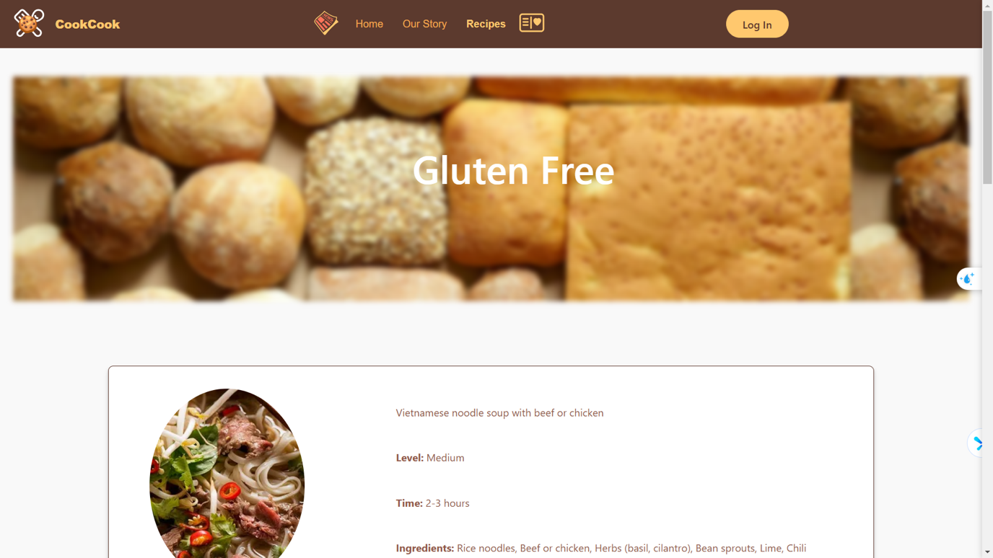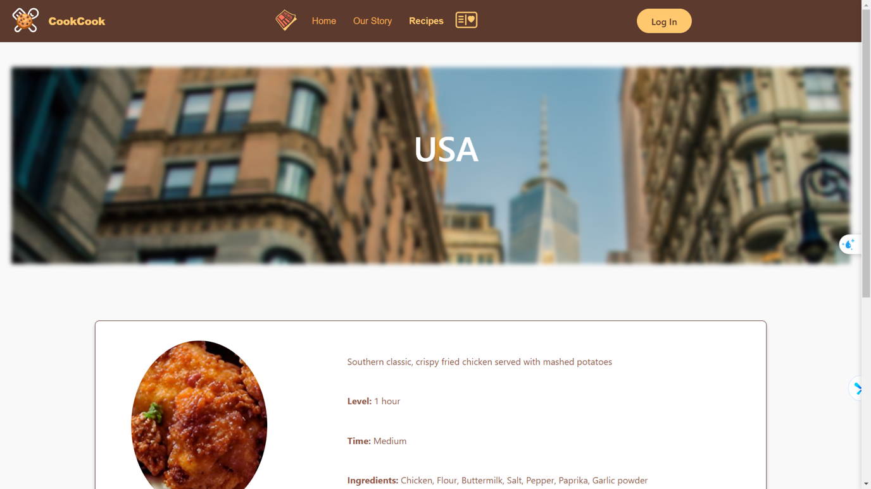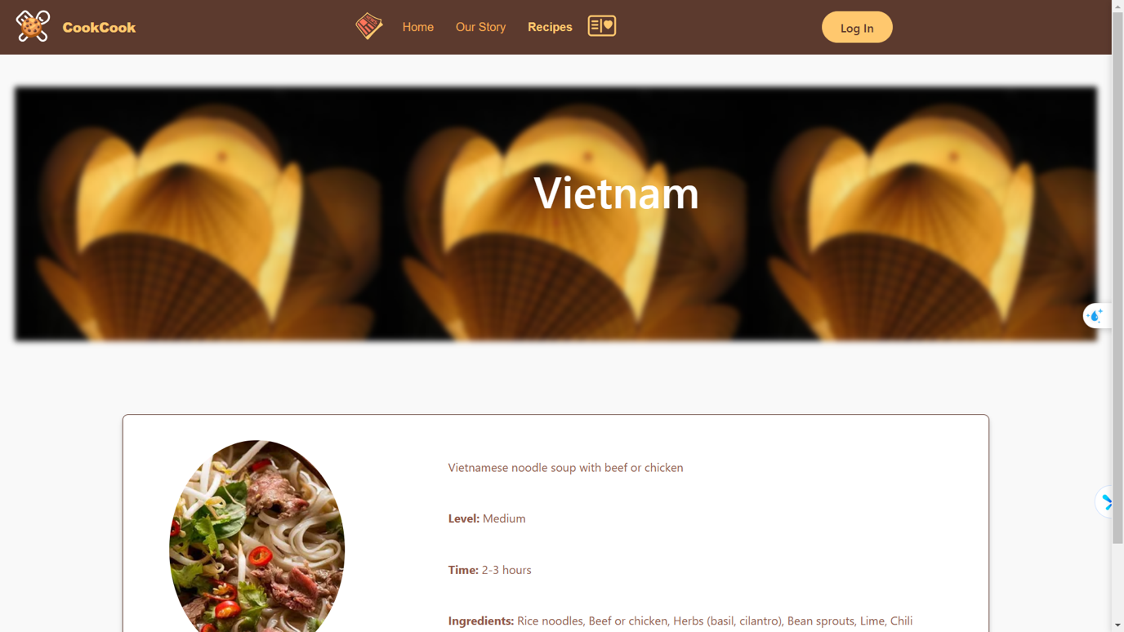

*(See Figure: Sorted Recipes Page)*

## **Recipe Page**

The **Recipe Page** displays detailed information about a selected recipe. There are two ways to access this page:

1. From the Homepage, by clicking on a featured recipe image.
2. From the Category Page, by selecting a category and clicking on a specific recipe within the category.

The Recipe Page includes:

* Recipe name, image, and description.
* Ingredients and step-by-step instructions.

*(See Figure: Recipe Page)*

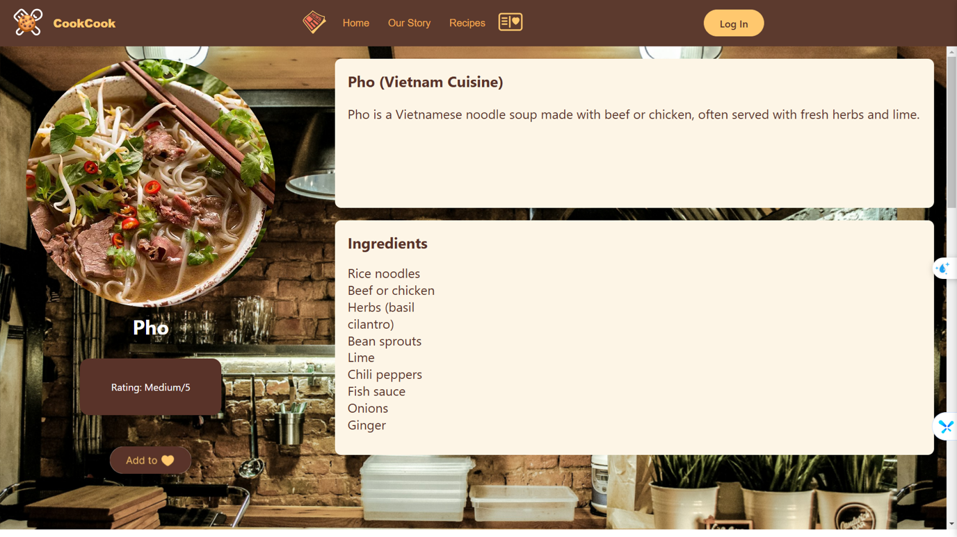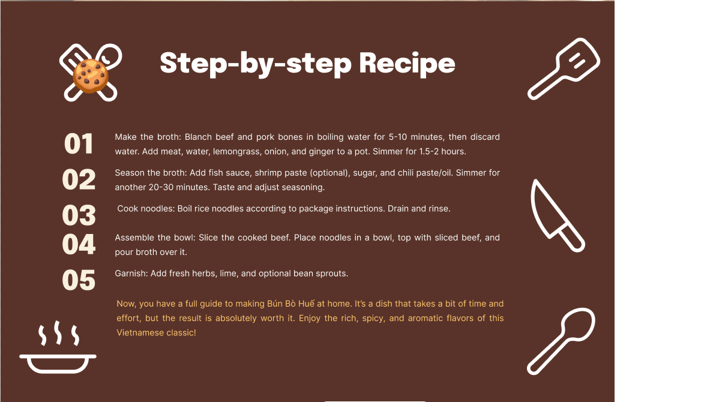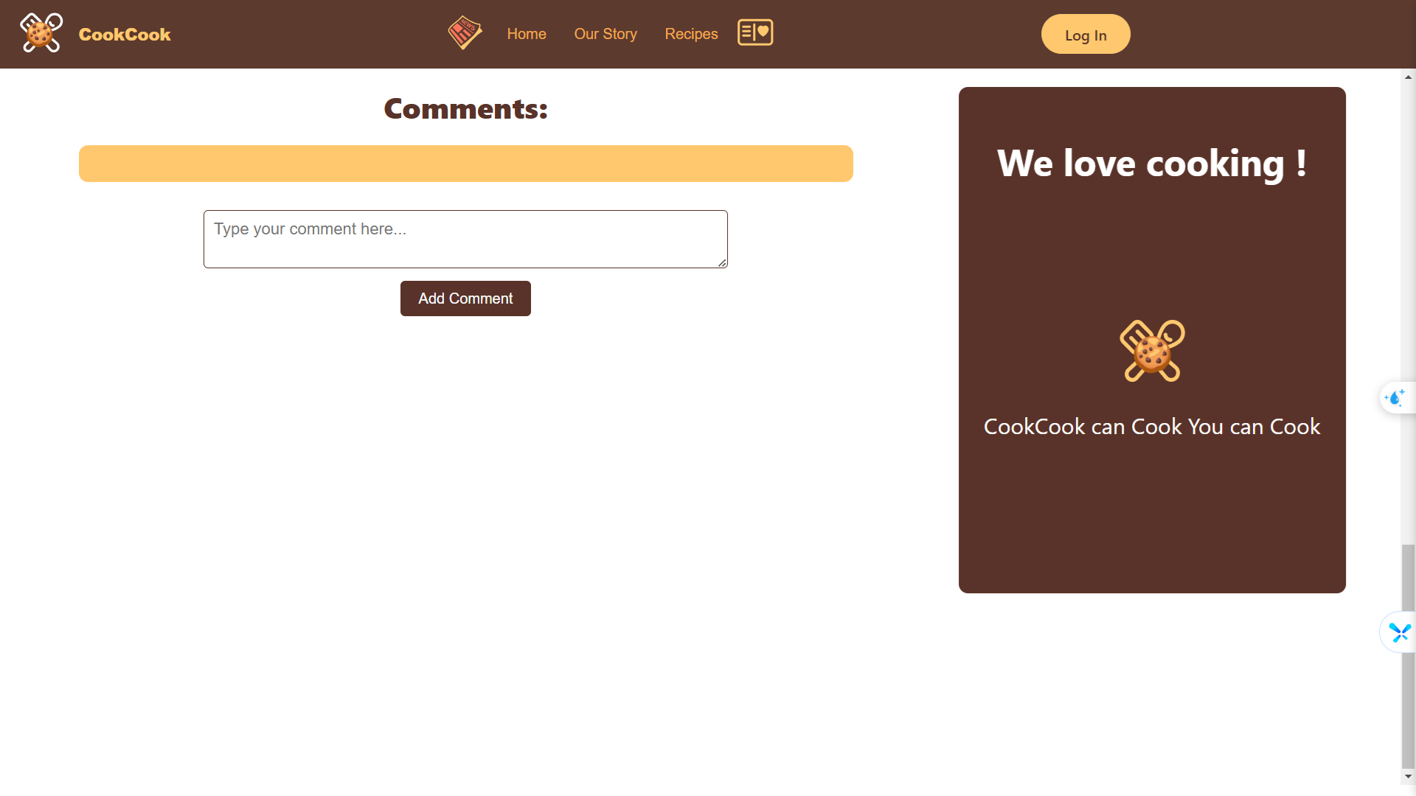

## **CookCook News Page**

The **CookCook News Page** is only accessible to logged-in users. It provides updates and articles related to recipes and food trends. This page helps users stay informed about seasonal recipes or new culinary techniques.

*(See Figure: CookCook News Page)*

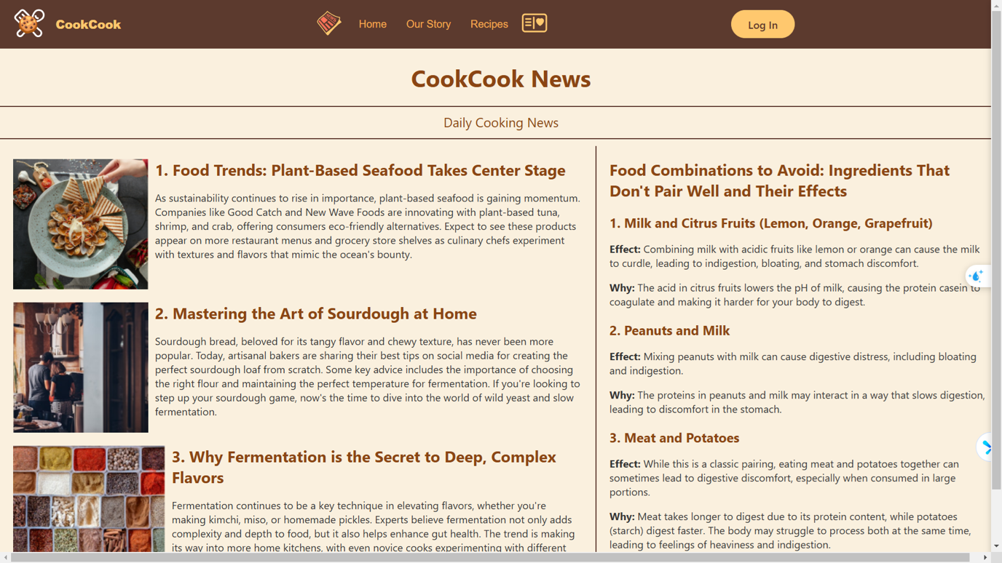

## **Add to Wishlist Page**

The **Wishlist Page** is a personalized feature requiring the user to be logged in. This page allows users to save recipes they find interesting but do not want to prepare immediately.

* Users can add recipes to their wishlist by clicking the "Add to Wishlist" button on the Recipe Page.
* If the recipe is already in the wishlist, the system displays an error message informing the user.

*(See Figure: Add to Wishlist Page)*

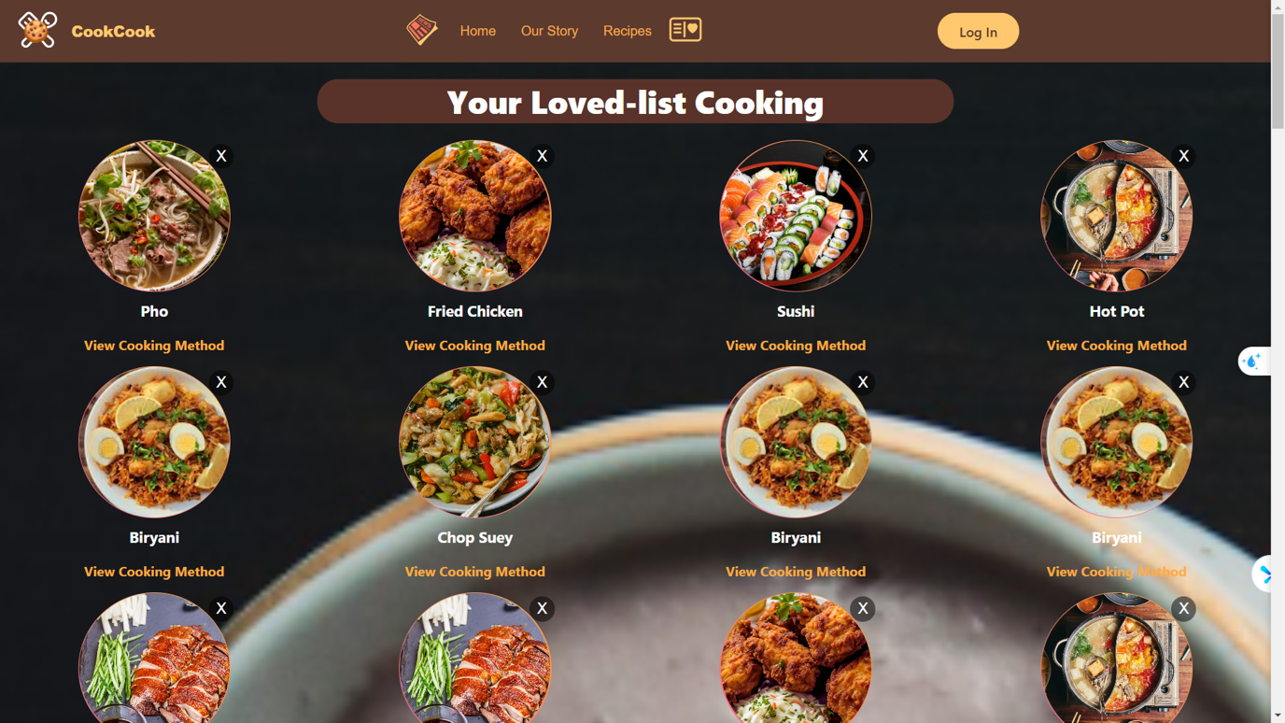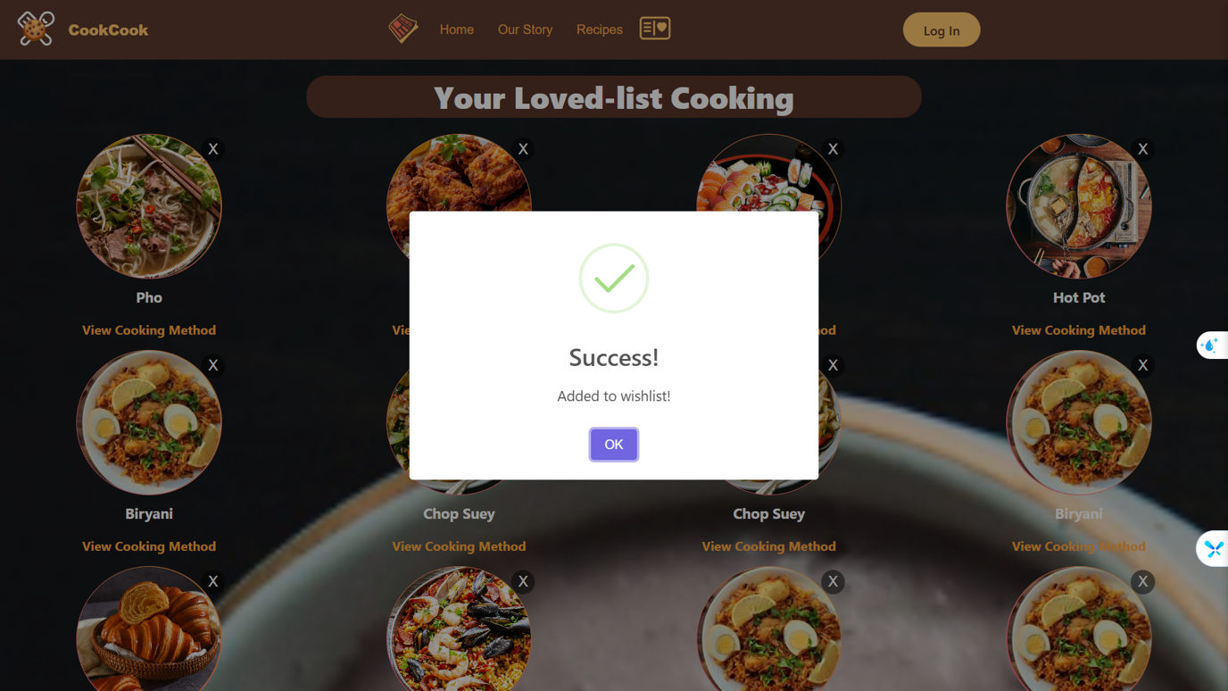

## **Summary**

The CookCook website is thoughtfully designed to offer seamless navigation and personalized experiences. From browsing recipes to creating a wishlist, every feature aims to enhance user convenience and engagement. Each page is equipped with clear functionality and aesthetic elements to guide users effectively, whether they are casual visitors or logged-in members.

# **IV. DISCUSSION AND CONCLUSION**

The CookCook website is designed to provide a seamless and engaging experience for users seeking food recipes, culinary inspiration, and personalized features such as wishlists and news updates. Throughout the development process, we have focused on creating a user-friendly platform that balances functional excellence with non-functional requirements to ensure usability, security, performance, and maintainability.

#### **Discussion:**

The system's design emphasizes accessibility and ease of use, ensuring that users with minimal technical skills can navigate and utilize its features. The inclusion of intuitive navigation, well-structured interfaces, and clear instructions enhances the overall user experience. By allowing users to save recipes to a wishlist, access news updates, and explore categories, the platform fosters deeper engagement and utility.

Non-functional requirements, such as performance optimization and data security, were prioritized to support a high-quality user experience. For instance, the system’s ability to handle simultaneous requests, fast response times, and robust data encryption ensures that it performs reliably even under high demand while maintaining user trust.

Operationally, the system relies on regular updates and monitoring to maintain stability and adapt to changing user needs. Legal considerations, such as adhering to copyright and privacy regulations, ensure compliance and build credibility among users. Moreover, support mechanisms, such as dedicated help channels and maintenance tools, empower administrators to manage the platform effectively.

#### **Conclusion:**

The CookCook website achieves its goal of delivering a comprehensive platform for culinary enthusiasts. Its well-structured interface, functional depth, and robust backend architecture combine to create a scalable and maintainable system. By meeting both functional and non-functional requirements, the platform not only fulfills immediate user needs but also lays the groundwork for future enhancements and scalability.

The development process underscores the importance of aligning system design with user-centric goals while adhering to technical and operational best practices. As the project evolves, the CookCook team remains committed to refining the platform to meet emerging demands, ensuring that it continues to be a valuable resource for its users.

# **V. REFERENCES**

1. Taste.com.au. (n.d.). *Top 100 easy dinner recipes*. Retrieved December 13, 2024, from <https://www.taste.com.au/quick-easy/galleries/top-100-easy-dinner-recipes/biccuul7>
2. Hardavellas, K. et al. (n.d.). *The growing role of data science in decision making*. Harvard Data Science Review. Retrieved December 13, 2024, from <https://hdsr.mitpress.mit.edu/pub/wjrl1qsq/release/3>
3. Epicurious. (n.d.). *Epicurious: Recipes, menu ideas, videos, and cooking tips*. Retrieved December 13, 2024, from <https://www.epicurious.com/>
4. Behance. (n.d.). *Food website projects on Behance*. Retrieved December 13, 2024, from <https://www.behance.net/search/projects/food%20website>